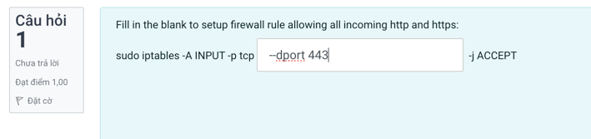

sudo iptables -A INPUT -p tcp --dport 80,443 -j ACCEPTsudo iptables -A INPUT -p tcp --dport 80,443 -j ACCEPT

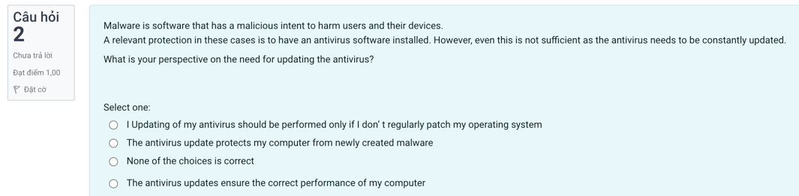

**The antivirus update protects my computer from newly created malware**.

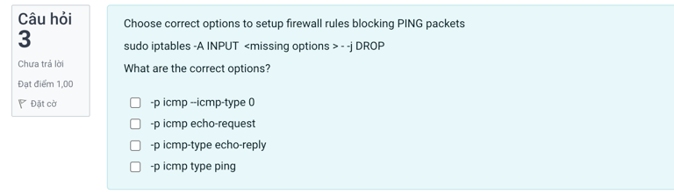

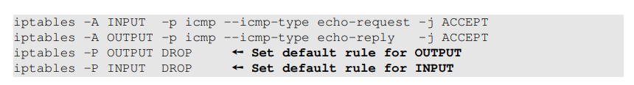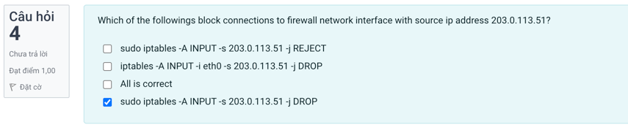?????

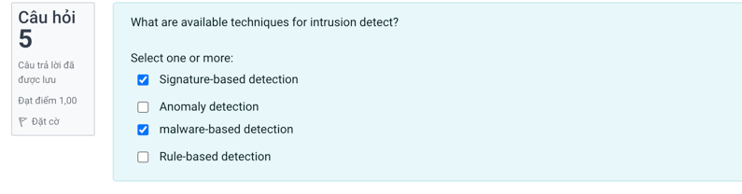  
????????

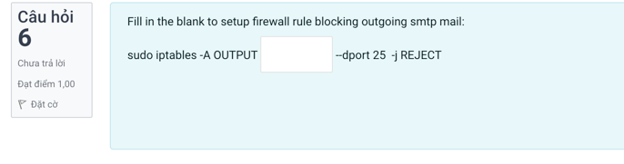

sudo iptables -A OUTPUT -p tcp --dport 25 -j REJECT

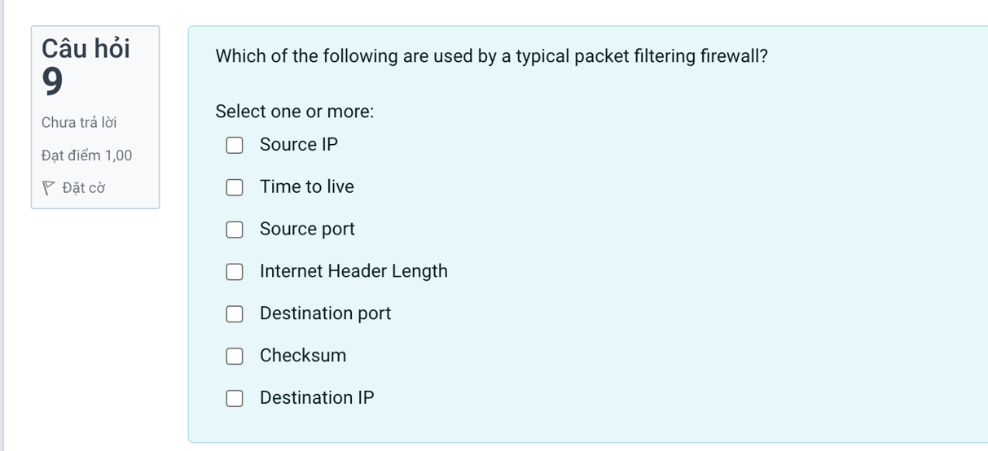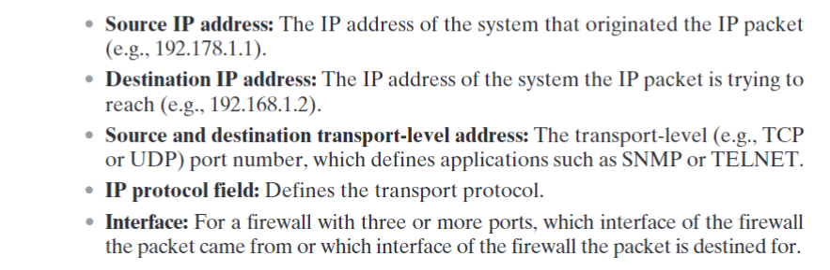

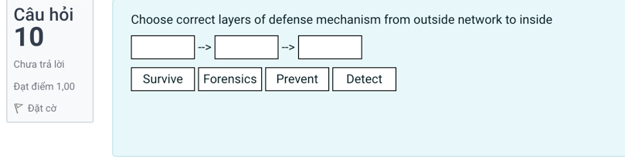

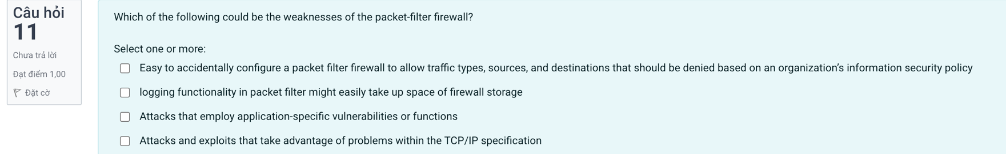

**A,c,d**

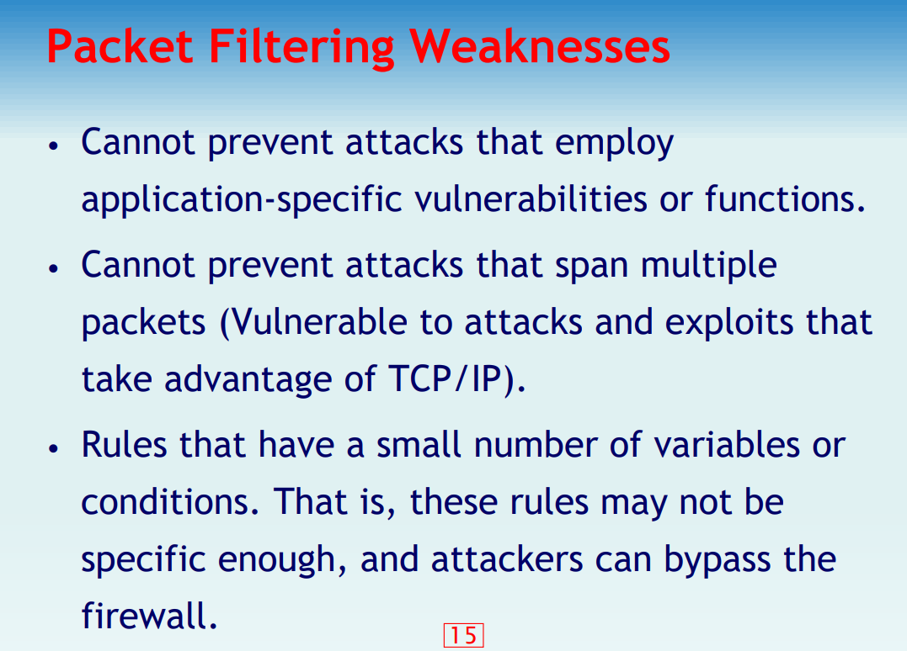

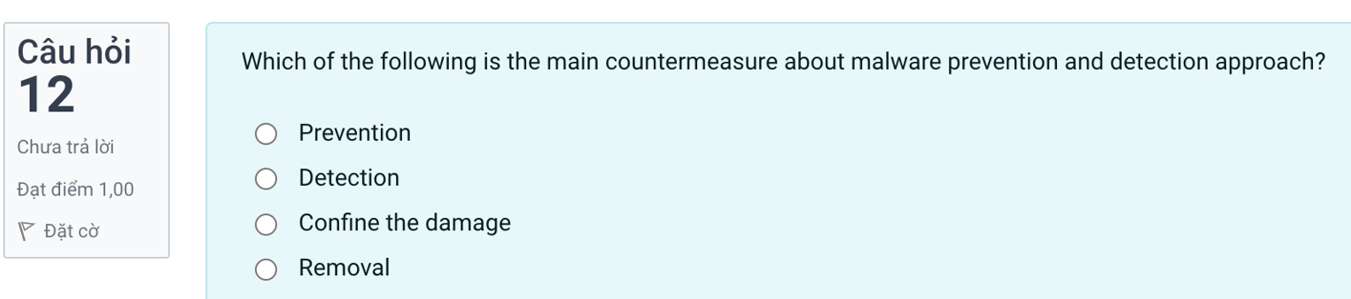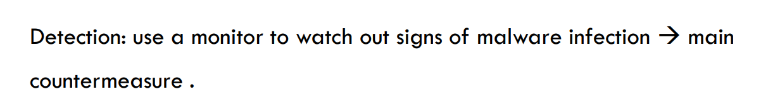

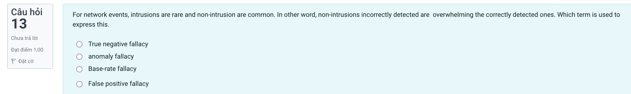?????

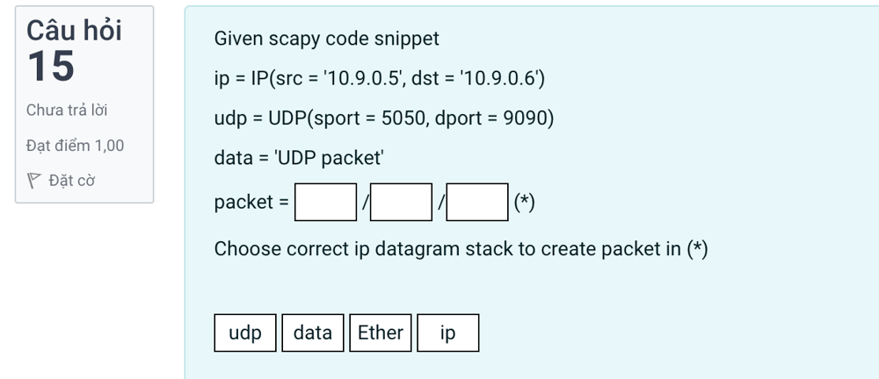 **packet = ip/udp/data**

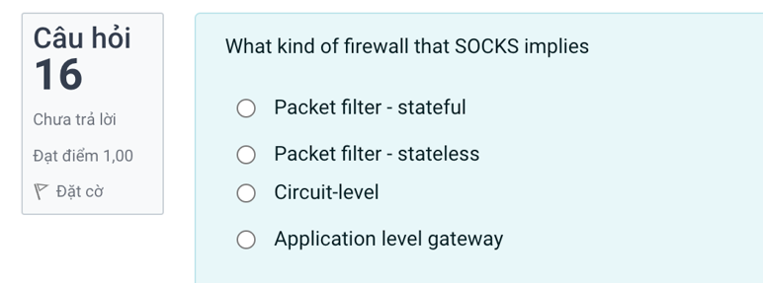 **Circuit-levelz**

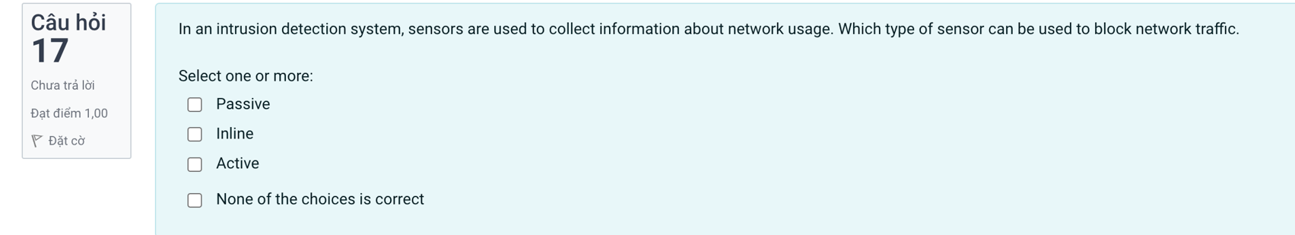



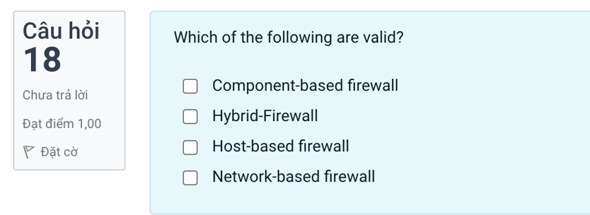**??????????????????????????**

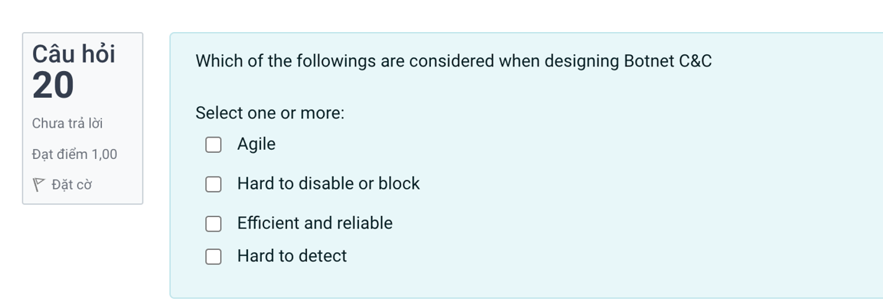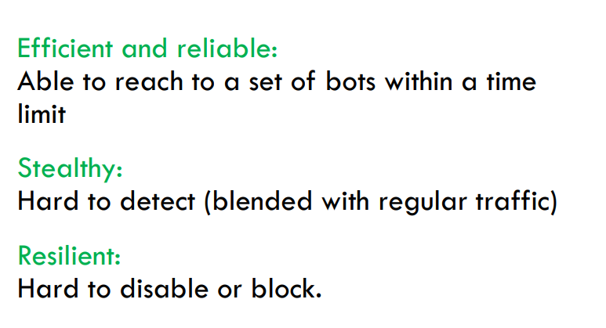

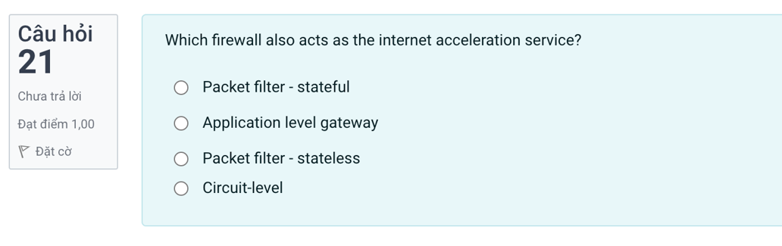

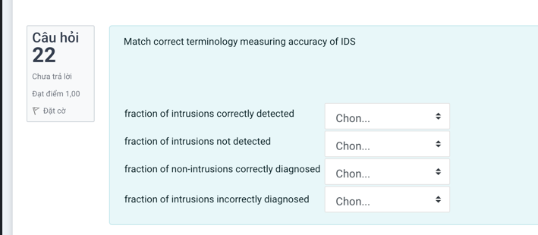

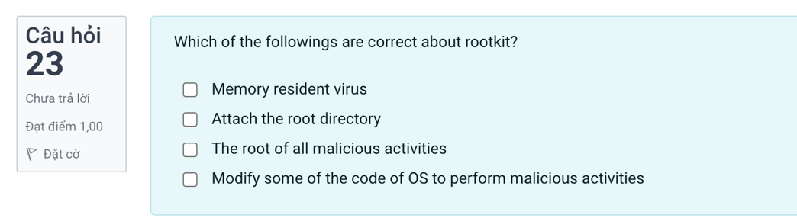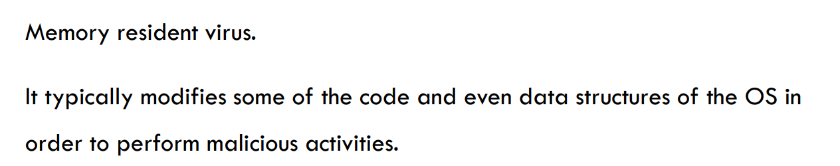

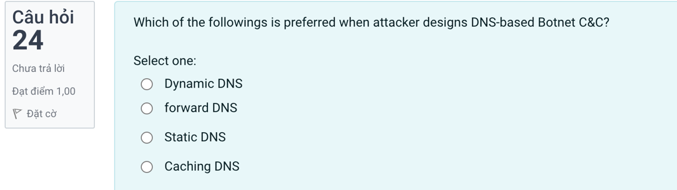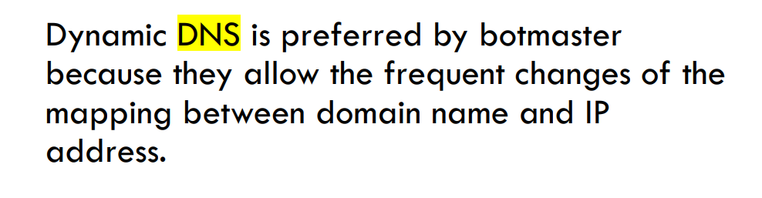

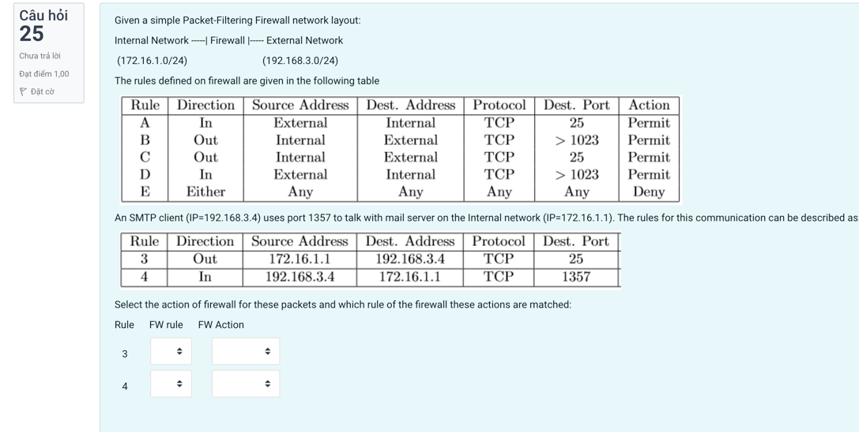

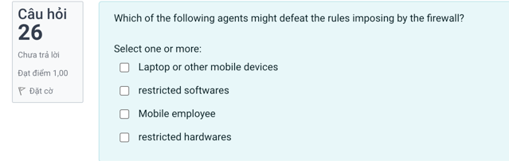

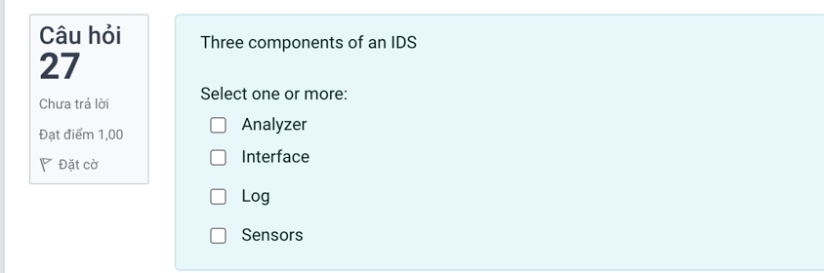

Analyzers -User interface- ???